**Course Code: CSA1557**

**Course: Cloud Computing and Big Data Analysis**

1. Aishwarya

192225114

1)Create a simple cloud software application for Flight Reservation System using any Cloud Service Provider to demonstrate SaaS include the necessary fields such as one way, round trip, From, to, Departure, Departure, Travelers & Class, Fare Type, International and Domestic Flights etc.

PROCEDURE:

Step1: Go to zoho.com.

Step 2: Log into the zoho.com.

Step 3: Select one application step.

Step4: Enter application name as flight booking.

Step 5: Created new application as flight booking.

Step 6: Select one form

Step 7: The software has been created.

IMPLEMENTATION:

STEP1: GOTO ZOHO.COM

STEP1: GOTO ZOHO.COM

STEP 2: LOGINTOTHE ZOHO.COM

STEP 3: SELECT ONE APPLICATION

STEP 4: ENTER APPLICATION NAME

Step 1:

Creating the form for flight booking application

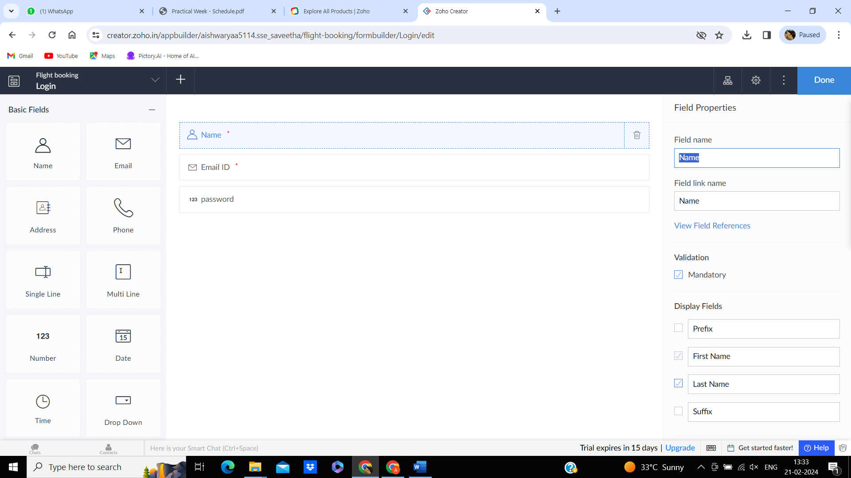

Step2: designing the form

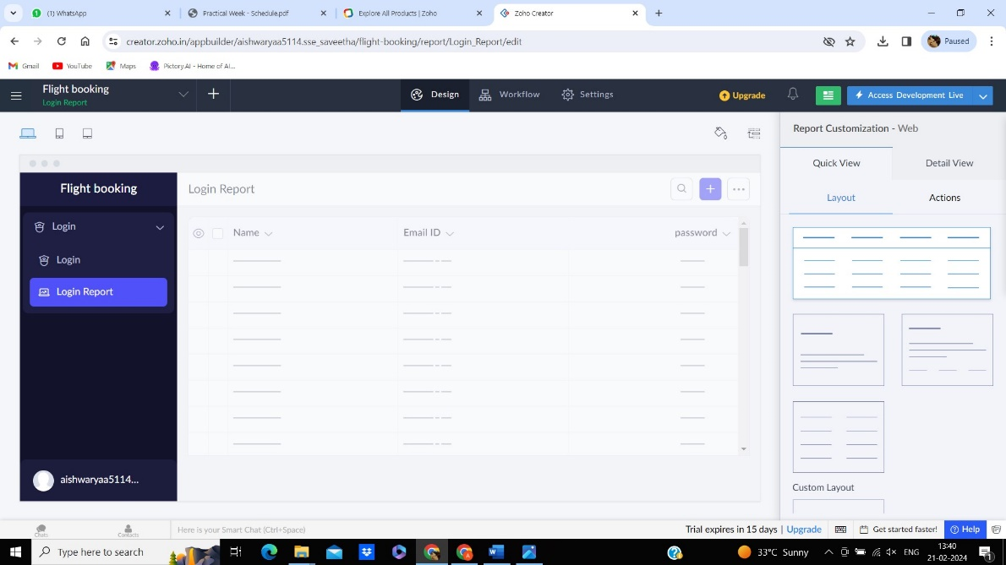

STEP 3: viewing the form in live , to see how it is working

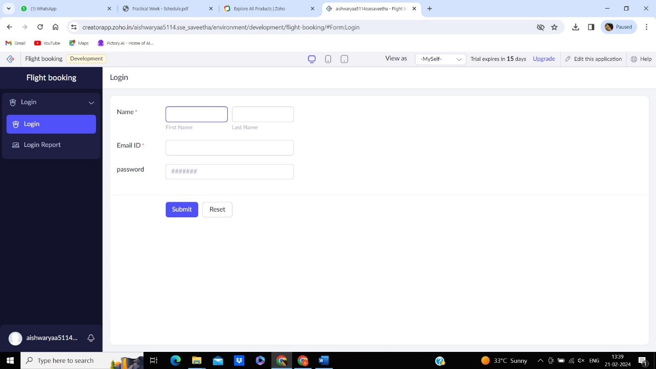

Step 4:

Creating an another form

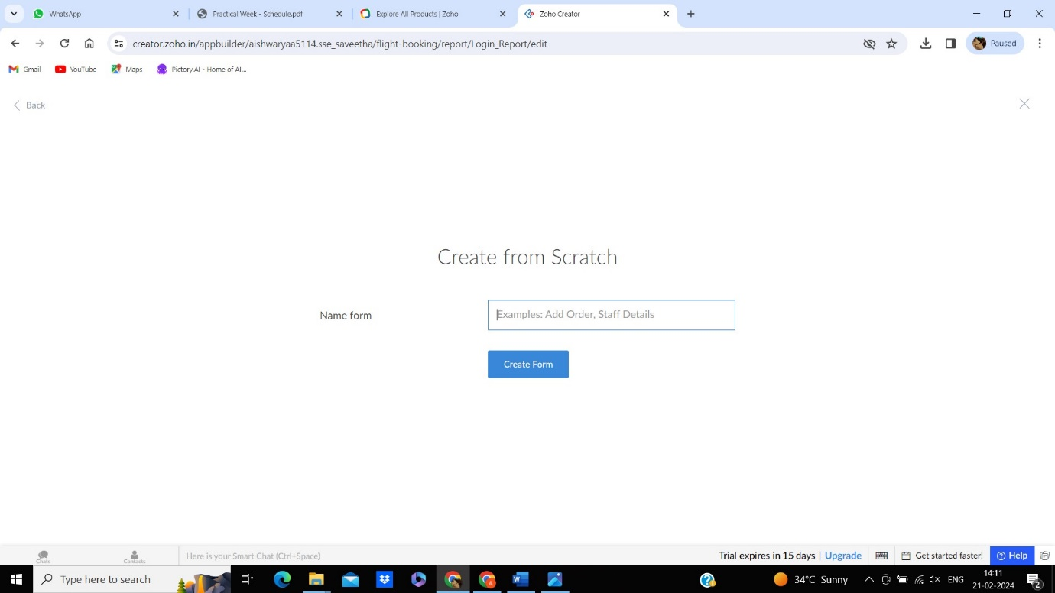

Step 5: again creating the information we want in this form

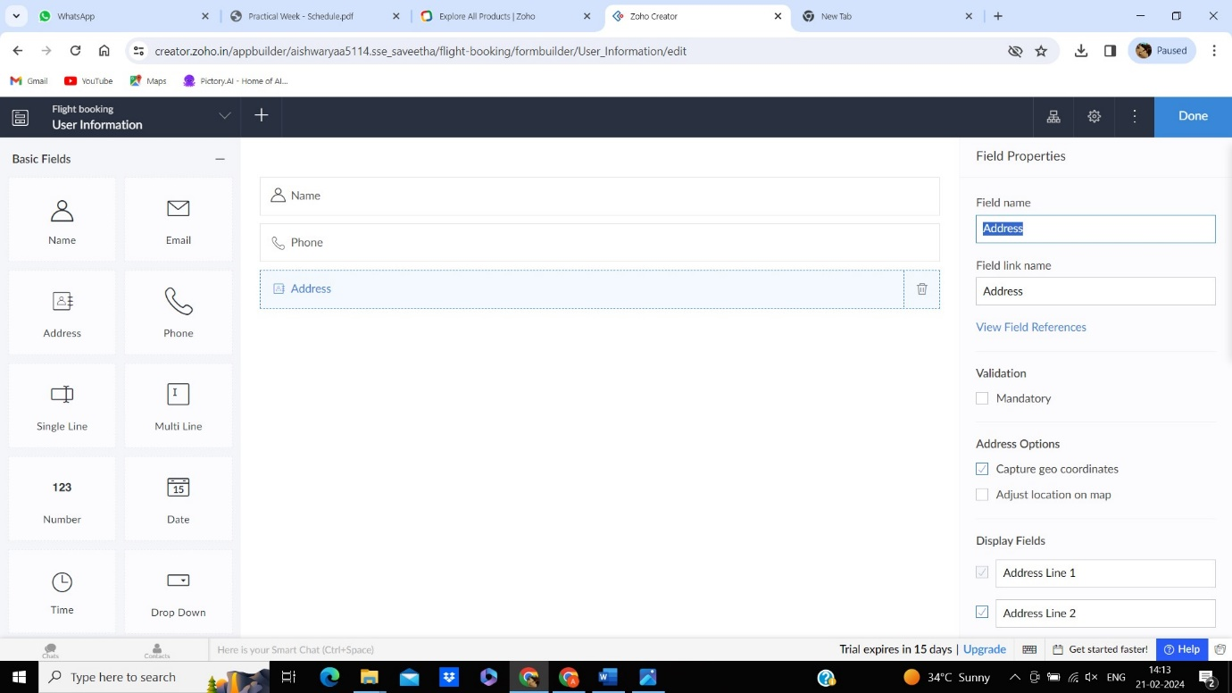

Step 6: designing the form

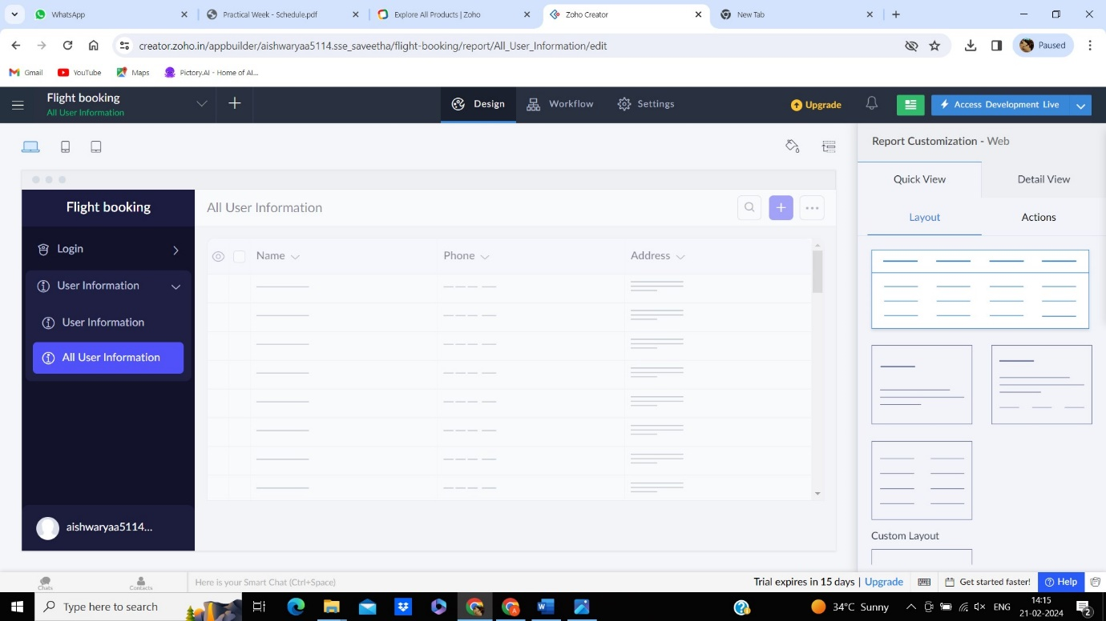

Step 7: viewing the form in live to see how it works

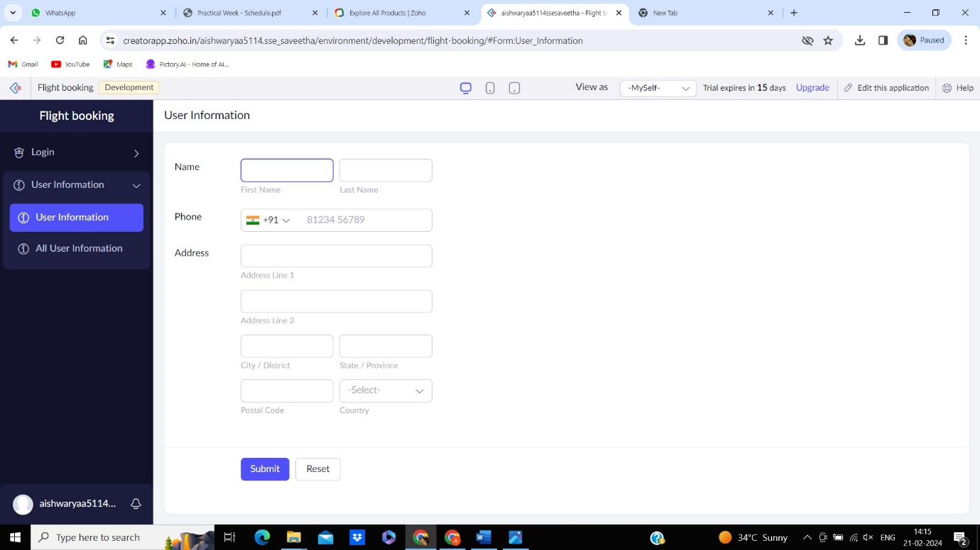

Step 8: third file creating

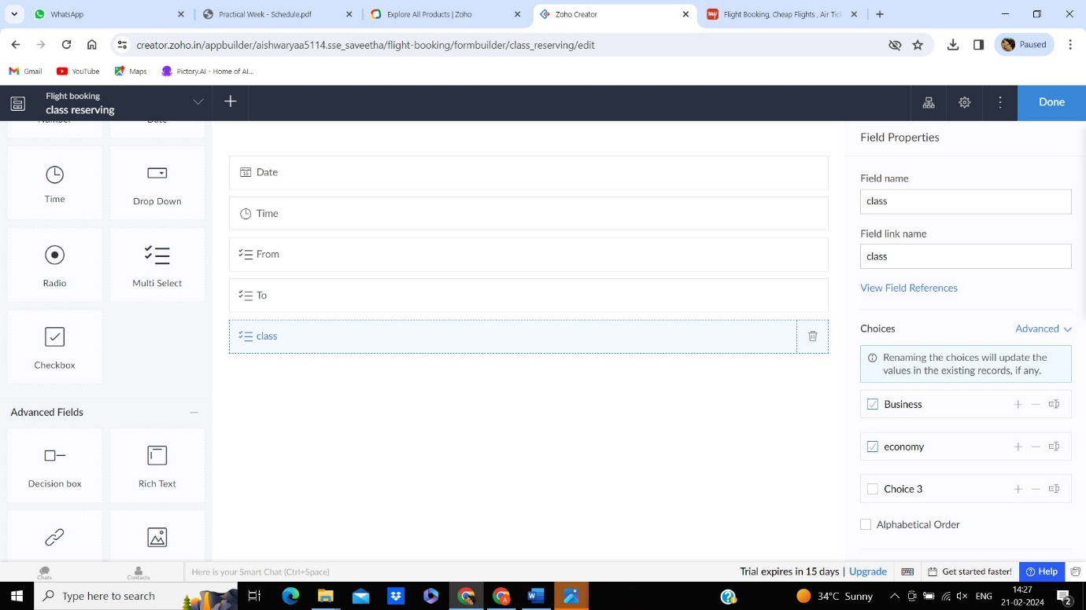

Step 9: designing the file

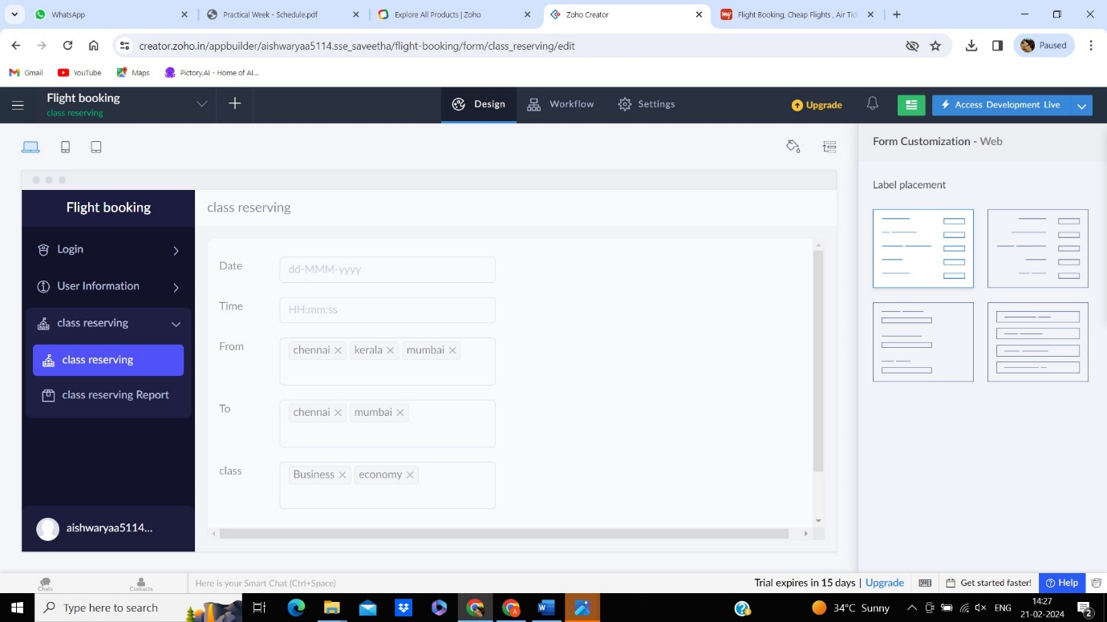

Step 10: viewing the file

